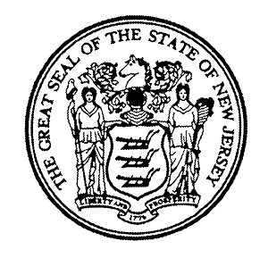

NJEA CONVENTION – Thursday, November 10th, 2016
NOTIFICATION FORM

I plan to attend the NJEA Convention:

____________________________________________________________________
NAME (Print) EMPLOYEE ID#

____________________________________________________________________
SIGNATURE DATE

____________________________________________________________________
SCHOOL REGION

*Please submit this form to your Principal no later than Tuesday, November 1, 2016.

Proof of attendance shall be submitted to your Principal upon return to school. Failure to provide the required proof of attendance shall result in the docking of pay for November 10, 2016.

*Note: The second day of the NJEA Convention, Friday, November 11th, is a holiday (Veterans Day).

