Additional resource documents for Sanctuary Campus events.

Sample Demand Letter

To [XXXXXX]:

This country’s institutions of higher education are foundations for scientific advancement, economic growth, technological innovation, cultural creation, and civic engagement. Through teaching, research, and service, our campus communities – students, faculty and instructors, and campus workers who support them – are engaged in a continuous defining and enacting of our nation’s highest ideals. While our institutions and our nation have too often fallen short of these high standards, the goals themselves are part of the engine that drives our progress as a nation.

President-elect Donald Trump’s hateful rhetoric threatens the climate in which this progress is possible. It has already taken a toll on our campuses. Swastikas, nooses, and racist graffiti are appearing on college campuses daily. Professors are being placed on watch lists. Tens of thousands of undocumented students face renewed threats of deportation. Muslim students and faculty were informed by the President-elect during his campaign that they will be forced to register on a federal database and may be issued government ID that lists their religion. Victims of sexual assault and hate crimes have heard Trump personally legitimate sexual violence, and signal that he will dismantle the Department of Education’s Office for Civil Rights, which has required college campuses to protect targets of sexual violence and to discipline those who have engaged in that violence. President-Elect Donald Trump has embraced morally repugnant ideas that are hostile not only to the values of the academy, but to the common good we strive for. The impending Trump presidency represents not only a threat to our basic academic and civic values, but to the people—students, community, faculty and staff—who make the educational enterprise possible.

[Our institution] must act to defend the ideals upon which it is founded and the people who bring them to life. We demand that the [institution] declare itself a Sanctuary Campus and make the following commitments to protect our community and our shared values:

- To refuse physical access to campus to U.S. Customs and Border Protection and U.S. Immigration and Customs Enforcement for investigating or detaining students, faculty, and campus workers and prohibit campus security from inquiring about or recording as to an individual’s immigration status or enforcing immigration laws.
- To refuse to voluntarily release academic records, employment records, or membership lists of organizations to the Department of Homeland Security, U.S. Immigration and Customs Enforcement, or other law enforcement agencies targeting members of the campus community solely on the basis of their immigration status, religion, racial or ethnic background, sex or gender identity, sexual preference, or political affiliation.
- To defend the principles of academic freedom and the free exchange of ideas from political interference. Specifically, institutions must decry and defend against the un-American practice of blacklisting faculty, whether they are tenured, untenured, or non-tenure-track. Institutions must similarly defend the free association rights of campus workers, students and their respective organizations.
- To aggressively protect the civil rights of all members of the campus community from crime. This must include actively protecting campus workers, students, and instructional staff against hate crimes and sexual assault, ensuring their physical safety, and providing for their ability to conduct their work in an environment free from intimidation and discrimination. This must include informing the entire college community that [our institution] will continue to use the guidelines for handling sexual assault cases released by the Office for Civil Rights on April 4, 2011 and expanded upon on April 29, 2014, and preserving the guidance regarding transgender students released on May 13, 2016.
- To provide the financial, academic, and social supports to students, faculty, and campus workers that are necessary to ensure true educational opportunity and economic well-being, recognizing that these supports are particularly vital for members of the campus community who may be the targets of government or private action solely on the basis of their immigration status, religion, racial or ethnic background, sex or gender identity, sexual preference, or political affiliation.

What we are facing is unprecedented; our response must also be unprecedented. Our students, our colleagues, and our community need to see that we will stand with them, and proactively reject any attacks on our campus. [Our institution] must take action to defend our campus from a presidential administration that has declared itself hostile to the American higher education community’s deepest values. Failure to meet these challenges is a betrayal of the college’s/university’s core academic mission and of the students, faculty, and campus workers who live this mission on a daily basis. We believe in a better and more just America, and we must demonstrate our convictions publicly.

We demand that [our institution] embrace the commitments described here, declare this a Sanctuary Campus, and work with campus leaders, student and employee organizations, and community groups to implement this declaration.

sanctuary campus action script

(Start with singing “We Shall Not Be Moved” - write out the lyrics and teach the crowd)

Hello, we thank you for being here.

Welcome to the #SanctuaryCampus movement.

We are the American Federation of Teachers, a union that champions fairness; democracy; economic opportunity; and high-quality public education, healthcare and public services for our students, their families and our communities.

We are joining thousands of faculty and students across the nation defending our campuses from the unprecedented attacks of President-elect Donald Trump. We demand that college and university administrators establish our campuses as public spaces of resistance and protection for our country's most vulnerable people - including undocumented immigrants, Muslims, Black people, Queer people, and all people of color. All over the country, we will make concrete our commitment to resisting Trump’s politics of hate.

It has only been a few weeks since Donald Trump’s election, and already Trump’s hateful rhetoric has taken a toll on our campuses. Swastikas, nooses, and racist graffiti are appearing on college campuses daily. Professors are being placed on watch lists and receiving death threats when they speak out against Donald Trump. Tens of thousands of undocumented students face renewed threats of deportation. Muslim students and faculty were informed by the President-elect during his campaign that they will be forced to register on a federal database and may be issued government ID that lists their religion. Victims of sexual assault and hate crimes have heard the future President of the United States say that he grabs women in the pussy and pay no electoral price for admitting this. He has signaled that he will dismantle the Department of Education’s Office for Civil Rights, which has required college campuses to protect targets of sexual violence and to discipline those who have engaged in that violence.

We should not be surprised that Trump is filling his cabinet with ideologues like Betsy DeVos and others who have made political careers out of targeting those who are vulnerable and dividing us from one another.

We are here today to defend our campus, as educators and community members, to say we will not accept this American nightmare we have awakened to.

We are afraid, as are many other communities that have been the target of hate in Trump’s campaign and regime thus far. Yet we will not let our fear keep us from speaking back. We will not be silent. We will not wait and see. Our history teaches that this strategy benefits only those who seek to spread hate and violence.

We are defending our campus today, and will continue to stand with our community in defiance of any attacks directed against any and all of the communities that are members of our campus. We are calling for [our institution’s] leadership to join us in this response and declare our campus a Sanctuary Campus for all.

Should they fail to respond to this call, we must be the leaders our institutions refuse to be. As #HandsOffOurCampus, we are calling for a new era of solidarity. A new era of knowing our neighbors, meeting each other, and trusting each other. We know that the only way to resist the possibility of fascism is to fight together with a showing of unprecedented unity.

We know that if we stand together, we can fight fear and hatred with hope and love. We know that we can make this campus a sanctuary for all.

In that vein, turn to your neighbor, the person next to you (or you can go around in a circle if there are a small number of people there) -- introduce yourself and say what brought you here today to draw the line.

Martin Niemoller (ne-ye-moy-er), a protestant priest and outspoken opponent to Hitler in Nazi Germany spent seven years in a concentration camp.

He survived, and afterwards this is what he wrote (can read the poem with the crowd repeating after the leader, or all together):

“First the came for the socialists and I did not speak out
Because I was not a socialist
Then they came for the trade-unionists and I did not speak out
Because I was not a trade-unionist
Then they came for the Jews, and I did not speak out
Because I was not a Jew
Then they came for me
And there was no one left to speak up for me”

But that is not our story.

Not this time.

We will not allow people to be divided out of fear and hate.

We will not succumb to hopelessness.

We will not leave anyone behind.

When they come for our immigrant communities, we will provide sanctuary.
(Everyone repeat: we will provide sanctuary)
When they force Muslims to register, we will provide sanctuary.
(Everyone repeat: we will provide sanctuary)
When they blacklist faculty for speaking out, we will provide sanctuary.
(Everyone repeat: we will provide sanctuary)
When they try to intimidate and attack anyone on our campus, we will provide sanctuary.
(Everyone repeat: we will provide sanctuary)

As the AFT, we call on [our institution] to make this campus a Sanctuary Campus. This campus serves as home to students, to campus staff, and to faculty, and our home must be safe for all of us. We must act in despite of fear. We must not choose to remain silent.

Not only because it is wrong

But because it will destroy us.

Today we renew our commitment to fairness and democracy. We renew our commitment to not only champion these values through our words, but through our actions. We invite [our institution] to join us.

Let us stand together, bound by fierce courage and solidarity, to face what is coming as one united people against hate in all forms.

Thank you for coming, and see you in the streets.

(Close by singing “They Tried to Stop Us” – you can see videos of people singing this song here and here)

Email templates to recruit friends

Hey Everyone,

The past few weeks have been challenging for me, [briefly describe your feelings and reactions here]. Last week I decided to do something about it -- I joined #HandsOffOurCampus and I hope you decide to join me.

On Thursday, January 19th, I’m helping the American Federation of Teachers (AFT) coordinate a nationwide Call for Sanctuary Campuses to demonstrate that faculty on campuses across the country will stand up to hate. Together we’ll amplify the call for #SanctuaryCampus by demanding that campus administration join the wave of institutions promising to protect all members of our campus community.

Here’s the link to my action: http://aft.to/sanctuarycampus

Across the country, thousands of us will tell college and university administrators we must establish public spaces of resistance and protection for our country's most vulnerable people - including undocumented immigrants, Muslims, Black people, Queer people, and all people of color. With this action, we are affirming for ourselves that this is a serious moment – that we will make concrete our commitment to resisting Trump’s politics of hate.

If you have friends in other cities that might want to attend a Call for Sanctuary Campuses action, send them this link and they can plug in their zip-code to find an action near them.

We cannot simply “wait and see.” Each action will end with a photo of the line, which will be posted online to truly show how fast our call for campuses to become sanctuaries for everyone is growing.

I hope you join me.

Sample Action Planning Meeting agenda

- Go and around and do intros: name, gender pronoun, what brings you to the room, and one thing you’re excited about with this action.

- Set a goal/purpose for the action: this will help clarify a location, time. Some questions to ask:
  - Why are you fighting for a Sanctuary Campus?
  - What do you want sanctuary at our institution to represent?
  - How many people will you need to be successful? Can you get that many people there within the next few days? (If not, maybe consider rethinking how many people you need to be successful)

- Use the goals to figure out your location. Some options:
  - A building that is central to the campus
  - An entrance to the campus to represent where sanctuary begins
  - A space on campus with lots of foot traffic

- Think about what the action will look like?
  - Delivering a letter? Organizing a sit-in? Holding a community space? Make sure to look at some of our ideas in the Action Guide. We encourage you to think beyond teach-ins, which tend to attract only the usual suspects and are hard to attract press coverage for.
  - Reflect on about what level of risk you’re interested in taking (arrest? being public? etc.)

- Create a recruitment plan. This should include a point person and a list of major influencers (individuals and organizations) you want to try and get to promote the action.

- Review the script and see whether you want to adapt it at all—if so, adapt it!

- Make a list of all the things that need to get done before the action and all the things that need to happen after the action -- and divide up roles. This gives more people opportunities to contribute, get engaged, and develop leadership skills. And it helps to prevent a few people from getting burned out. Some ideas of roles
  - Action Leaders - two people who will run the program of the action.
  - Logistics - someone who can make sure you have everything you need for the action, including things that need to be printed.
    - Signs and banners (see artwork below)
    - Sign in sheets
    - Any other materials you come up with
  - Social Media Roles
    - One person to Facebook Live the action
    - People to live tweet and do a live stream on Facebook. Include #SanctuaryCampus and #HandsOffOurCampus so we can track the actions. Don’t forget the link to the tele-townhall signup page!
    - Official Photographer and videographer
    - Write a blog post for AFT blog after the action and include photos of the event.
  - Art Coordinator
    - Make flyers, posters, and banners
    - Make a small leaflet to hand out
    - Coordinate getting materials to the action
  - Recruitment
    - Confirming people who have said they want to attend
    - Creating an outreach plan to get even more people to the action
  - Outreach Day Of
    - Print out leaflet template
    - Bring sign in sheet and make sure everyone there signs in
    - Talk to passersby about what you’re doing and invite them to sign the sign in for more info and attend the tele-townhall
    - Make sure all sign ups get inputted into Action Network

- Make a Tele-townhall Next Steps watch party plan
  - Create a team to coordinate the watch party
  - Choose a location so you can advertise the tele-townhall to the people who come to your action.

- Make clear next steps and conclude the meeting. Set up a method of communication, like a group text thread, so you can stay in touch leading up to the action.

- Invite meeting attendees to the AFT National Action Planner debrief call on Tuesday, January 24 at 8:00pm EST (RSVP at http://aft.to/sanctuarycampusTTH )

How to Go Viral on Facebook Live

First - here is a one hour webinar that is extremely helpful if you have time to watch before the action.

If you don’t have time to watch that, here are the major keys from the webinar:

- Have the caption you want for the video copied in a note in your phone or easily accessible since you can't edit it once you use it. It should have the link to the sign-up page for the AFT tele-townhall and a short description of what the action is doing.

Sample text: “Today (our institution) is joining the national call to become a #SanctuaryCampus! We are demanding (our chancellor/president) publicly announce that tell President-elect Trump that our message is clear: #HandsOffOurCampus

If you want to join us in building the call for sanctuary campuses, sign up for the national AFT tele-townhall happening Tuesday, January 24 at 8:00pm EST or to learn how to attend the AFT higher ed conference → http://aft.to/sanctuarycampusTTH

- In general, you should be acting as if you're a journalist live reporting and narrating the action for the audience.
  - Average watch time for Facebook Live is only 10 seconds -- so you need to be working to keep people engaged and consistently update new viewers about what the action is, why it is happening, and what they can do
  - Right before the action starts, right after it ends, and when there is a dull moment feel free to do an interview with attendees asking them who they are and why they are at the action.

- You should constantly be asking viewers to do these two things:
  - Share the video (“Share this video so that more people can see what Sanctuary Campus movement looks like!”). This is how we get views -- when these streams go viral.
  - Sign up for the national AFT tele-townhall happening after the national day of action (“Make sure to check out the link in the description and sign up for the national AFT tele-townhall so you can hear what’s next for the sanctuary campus movement!”)

- Some Other Random Keys
  - You're gonna want a battery pack since streaming kills your battery.
  - Practice at home. Make sure the video comes in the right way and that you know how to add the caption.
  - Hold the camera horizontal.
  - Don't get discouraged if there are not a ton of people watching -- live streams get most of their views after it ends (like 50x the views).
  - Ask a friend at another campus to commit to watching it the whole time and be texting you with live feedback -- like if we can't hear you or like it's really boring or something or the video is sideways.

Banner and Sign ideas & AFT logo

Sign/Banner Ideas:
- #SanctuaryCampus
- #HandsOffOurCampus
- MAKE (YOUR CAMPUS) A SANCTUARY CAMPUS
- We will care for and protect one another
- There comes a time when silence is betrayal
- Your voice matters, You matter
- No papers, no fear, sanctuary is HERE
- Faculty Against Deportations
- Protect Academic Freedom, Don't Comply with Black Lists
- (President name), which side are you on?
- Against Islamophobia #SanctuaryCampus

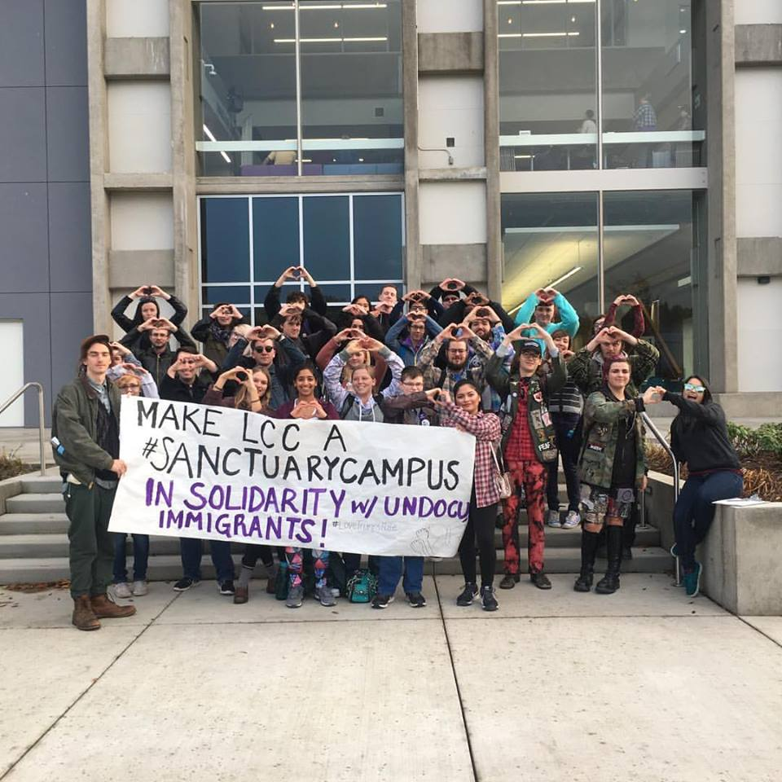

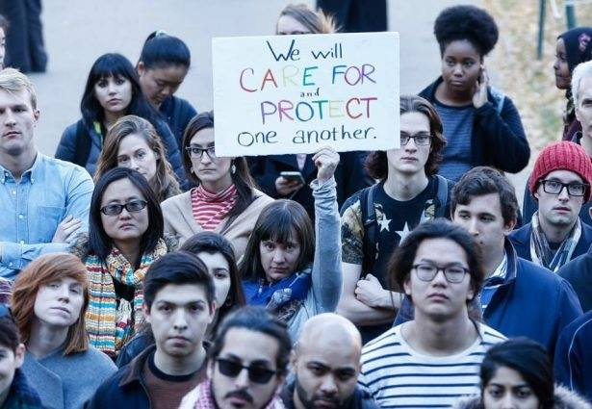

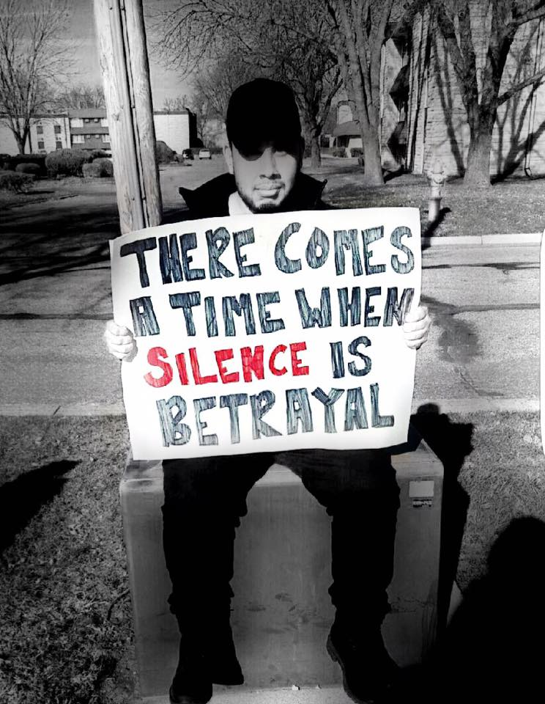

Coalition Partners

For additional resources, you can reach out to these groups that have been active in the fight for sanctuary campuses:

Cosecha
http://www.lahuelga.com/
Cosecha is a nonviolent movement fighting for permanent protection, dignity and respect for the 11 million undocumented immigrants in the United States. Cosecha has held a national day of action calling for #SanctuaryCampus with more than one hundred campuses participating.

End Rape on Campus
http://endrapeoncampus.org/
End Rape on Campus (EROC) works to end campus sexual violence through direct support for survivors and their communities; prevention through education; and policy reform at the campus, local, state, and federal levels.

MPower Change
https://mpowerchange.org/
MPower Change is a grassroots movement rooted in diverse Muslim communities throughout the United States who are working together to build social, spiritual, racial, and economic justice for all people.

The Alliance to Reclaim Our Schools
http://www.reclaimourschools.org/
The Alliance to Reclaim Our Schools (AROS) is an unprecedented alliance of parent, youth, community and labor organizations that together represent over 7 million people nationwide. We are fighting to reclaim the promise of public education as our nation's gateway to a strong democracy and racial and economic justice.

American Association of University Professors
https://www.aaup.org/
Since 1915, the AAUP has championed academic freedom, advanced shared governance, and promoted economic security for all who teach and research in higher education.

American Federation of Teachers – Higher Education
http://www.reclaimhighered.org/
The American Federation of Teachers represents over 100,000 of the one million full and part-time nontenure-track faculty in the US, making us the largest union of faculty and of contingent faculty.

Sample media Advisory

Media Advisory
January 19, 2017

Contact:
Ginny Myers, vmyers@aft.org, 202-585-5847
Your name, your email, your phone

Faculty across the Country Call for (Our Campus) to Become Sanctuary Campus as Part of National Day Action

They are demanding (our campus) speak out against the dangerous policies of the incoming Trump administration.

The American Federation of Teachers, a union that champions fairness; democracy; economic opportunity; and high-quality public education, healthcare and public services for our students, their families and our communities, is hosting a national day of action on Thursday, Jan. 19th defending our campuses from the unprecedented attacks of President-elect Donald Trump. We demand that college and university administrators establish our campuses as public spaces of resistance and protection for our country's most vulnerable people - including undocumented immigrants, Muslims, Black people, Queer people, and all people of color. All over the country, we will make concrete our commitment to resisting Trump’s politics of hate.

President-elect Donald Trump’s hateful rhetoric threatens the climate in which this progress is possible. It has already taken a toll on our campuses. Swastikas, nooses, and racist graffiti are appearing on college campuses daily. Professors are being placed on watch lists. Tens of thousands of undocumented students face renewed threats of deportation. Muslim students and faculty were informed by the President-elect during his campaign that they will be forced to register on a federal database and may be issued government ID that lists their religion. Victims of sexual assault and hate crimes have heard Trump personally legitimate sexual violence, and signal that he will dismantle the Department of Education’s Office for Civil Rights, which has required college campuses to protect targets of sexual violence and to discipline those who have engaged in that violence. President-Elect Donald Trump has embraced morally repugnant ideas that are hostile not only to the values of the academy, but to the common good we strive for. The impending Trump presidency represents not only a threat to our basic academic and civic values, but to the people—students, community, faculty and staff—who make the educational enterprise possible.

This Thursday, faculty, students, and campus staff on more than 25 campuses across the country will be gathering in on their campuses to call on campus administrators to declare their institutions as sanctuary campuses.

[Our institution] must take action to defend our campus from a presidential administration that has declared itself hostile to the American higher education community’s deepest values. Failure to meet these challenges is a betrayal of the college’s/university’s core academic mission and of the students, faculty, and campus workers who live this mission on a daily basis. We believe in a better and more just America.

WHO: American Federation of Teachers, students, and community allies.
WHERE: 50 campuses across the country. For specific details about a demonstration near you, go to http://aft.to/sanctuarycampus
WHEN: Throughout the day of Thursday, Jan. 19th.

# # # #

The AFT represents 1.6 million pre-K through 12th-grade teachers; paraprofessionals and other school-related personnel; higher education faculty and professional staff; federal, state and local government employees; nurses and healthcare workers; and early childhood educators. For more information: www.aft.org

