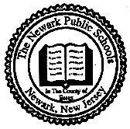
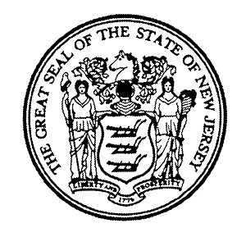
THE NEWARK PUBLIC SCHOOLS
NEWARK, NEW JERSEY 07102-3091

NJEA CONVENTION – Thursday, November 5th, 2015
NOTIFICATION FORM

I plan to attend the NJEA Convention:

____________________________________________________________________
NAME (Print) EMPLOYEE ID#

____________________________________________________________________
SIGNATURE DATE

____________________________________________________________________
SCHOOL REGION

*Please submit this form to your Principal no later than Thursday, October 29, 2015.

Proof of attendance shall be submitted to your Principal upon return to school. Failure to provide the required proof of attendance shall result in the docking of pay for November 5th 2015.

*Note: The second day of the NJEA Convention, Friday, November 6th, is a district holiday (Puerto Rico Day).

