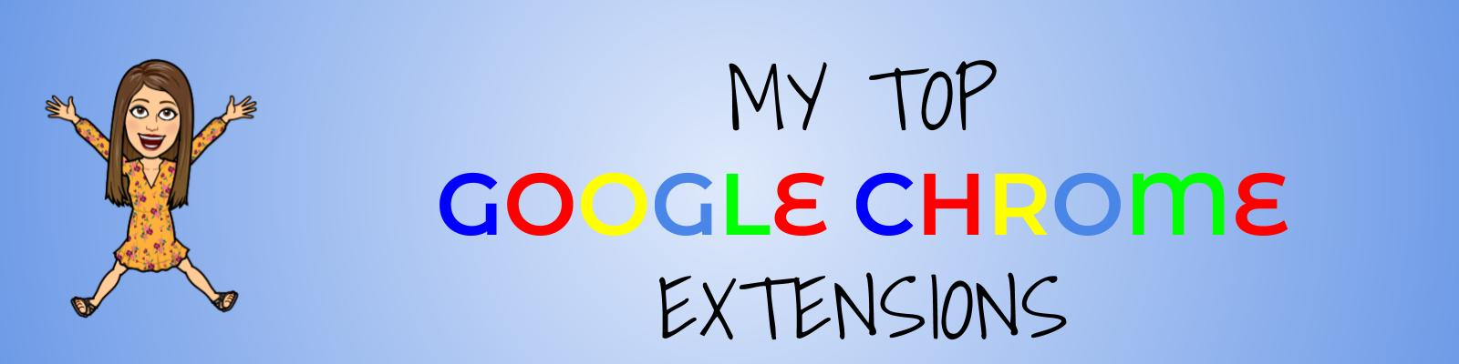

Adding Google Chrome extensions is so easy and FREE! Here are some of my favorite Chrome extensions for Distance Learning!

Bitmoji - This is one of my FAVORITE extensions, in case you couldn’t tell. You can actually use the bitmoji extension in so many ways.

Here are some of the ways I’ve used it:
🍎 put Bitmojis on class slides
🍎 add Bitmojis to bookmarks, class rules, or end of the year awards
🍎 insert Bitmojis on student work

It is very easy to use. You just click on the bitmoji extension at the top of your omnibox and then just copy and paste them right into your slides or student work.

Emoji Keyboard - This extension is really cool too. Use it to add emojis to your announcements, slides, or Google Classroom! I used it when I posted an assignment or on my Google Classroom topics.

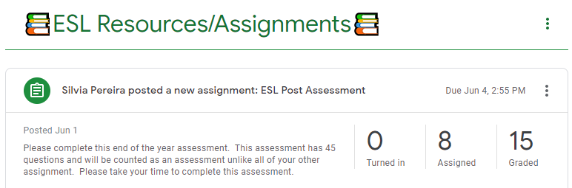

Custom Cursor - This makes your cursor something fun for your online class meetings or screen recording when doing screencastify.

Screencastify - Easily record your screen, yourself, or both! The great thing about screencastify is that you can add it directly to your Google Classroom!

Giphy - Easily copy and paste GIFs and stickers!

Mote - Easily send voice messages to your students in Google Docs, Slides, and Sheets. Mote was designed to comment or provide feedback in a faster and friendlier way.

Google Keep - If you love to organize your notes and to-do lists, then this extension is great for you. You can access it from your phone, apple watch, or computer.

